SQL QUERIES

1)select top 10* from [DataDB].[dbo].['sample-csv-file-for-testing$'] ORDER BY[ Gross Sales ] DESC

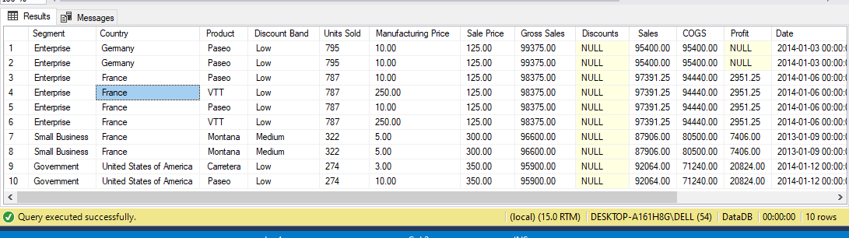

2) select top 3 *from [DataDB].[ dbo].['sample-csv-file-for-testing$']

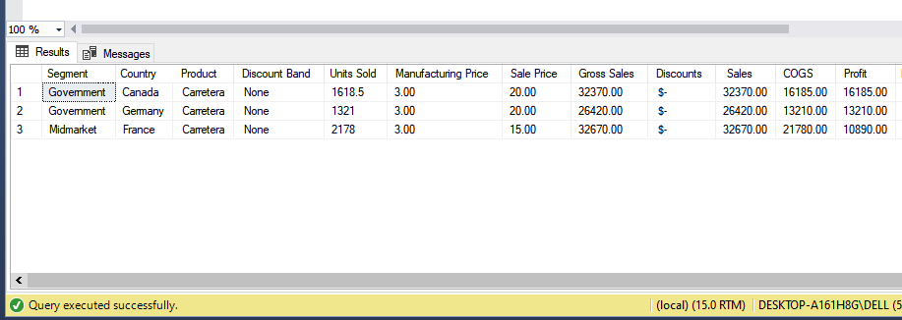

3) select top 5* from [DataDB].[dbo].['sample-csv-file-for-testing$']ORDER BY [ Profit ] DESC;

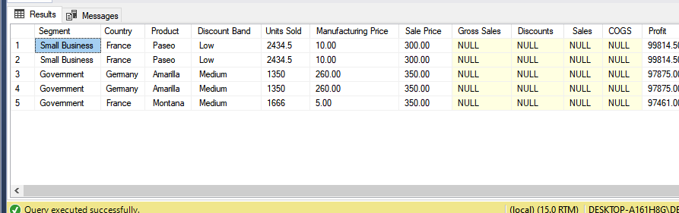

4) select Country, SUM([ Sales ]) TOTAL_Sales From [DataDB].[dbo].['sample-csv-file-for-testing$'] GROUP BY Country

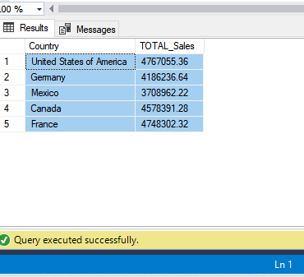

5) select Country, SUM([ Profit ]) TOTAL_Profit from [DataDB].[dbo].['sample-csv-file-for-testing$'] GROUP BY Country

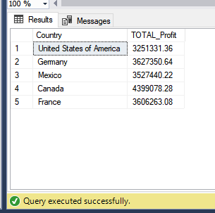

|  |  |
| --- | --- |
|  |  |
|  |  |
|  |  |
|  |  |
|  |  |

6) select Segment, SUM([ Sales ]) TOTAL_Sales from [DataDB].[dbo].['sample-csv-file-for-testing$'] GROUP BY Segment ORDER BY TOTAL_Sales DESC;

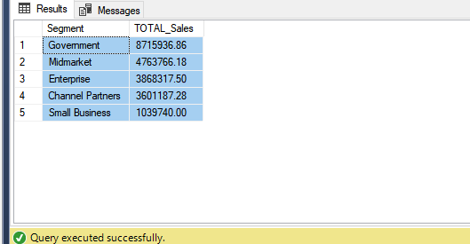

7) select Segment, SUM([ Sales ]) TOTAL_Sales from [DataDB].[dbo].['sample-csv-file-for-testing$'] GROUP BY Segment having SUM([ Sales ])>2000000 ORDER BY TOTAL_Sales DESC;

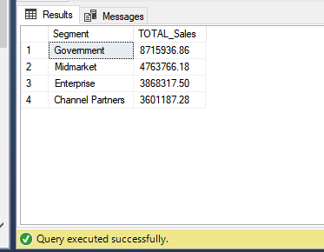

|  |  |
| --- | --- |
|  |  |
|  |  |
|  |  |
|  |  |

8)select * from dbo.['Table 2$'] LEFT JOIN dbo.['Table 1$']on dbo.['Table 2$'].[ Sales ]=dbo.['Table 1$'].[ Sales ]

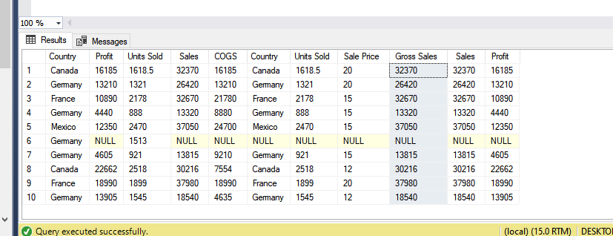

9) select*from dbo.['Table 2$']RIGHT JOIN dbo.['Table 1$']on dbo.['Table 2$'].Country=dbo.['Table 1$'].Country

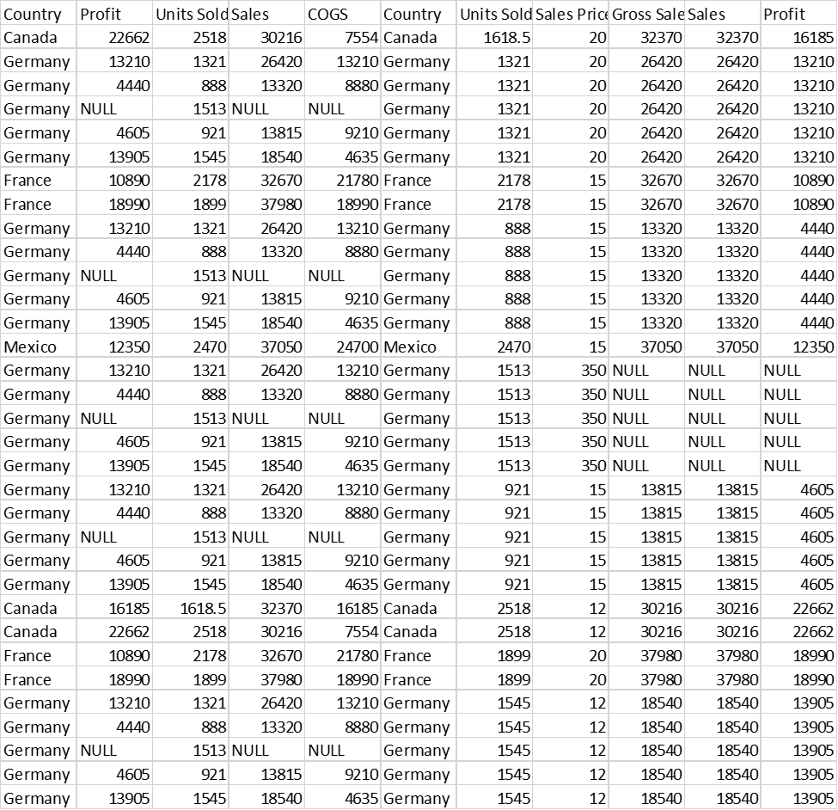

10)select *from dbo.['Table 2$']FULL OUTER JOIN dbo.['Table 1$']on dbo.['Table 2$'].[Units Sold]=dbo.['Table 1$'].[Units Sold]

